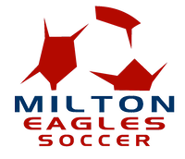
Milton High School Soccer Corporate Sponsorship Levels
Bronze Level - $250
- Small Company Logo on Sponsor Banner
- Company Logo on Milton Soccer Website with Link
- 1/4 page Ad in the Game Day Flyer
Silver Level - $500
- Medium Company Logo on Sponsor Banner
- Company Logo on Milton Soccer Website with Link
- 1/4 page Ad in the Game Day Flyer
- Announcement on PA System
Gold Level - $750
- Large Company Logo on Sponsor Banner
- Company Logo on Milton Soccer Website with Link
- 1/2 page ad in the game day flyer
- Announcement on PA System
Platinum Level - $1000
- Extra Large Company Logo on Sponsor Banner
- Company Logo on Milton Soccer Website with Link
- Full Page Ad in the Game Day Flyer
- Announcement on PA System

